PC Automotive Maxi Blade Fuse Clip

Vertical Mount - for .312 x .032 Maxi Blade Fuses
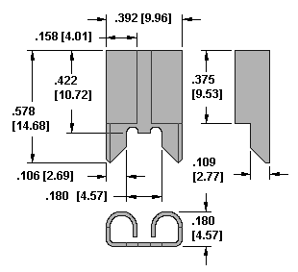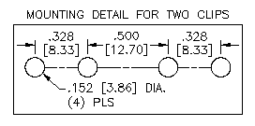
  Cat. No. 3555
  PC Mount
  Material: .020 [0.50] Copper, Tin Nickel Plate
  Current Rating: 60 Amps
  Click to Request Samples

Keystone Electronics PC Automotive Maxi Blade Fuse Clip 355.

